THE LIVING STONES – March 19, 2023
Opening Scripture:
1 Peter 1:1-2: 1 Peter, an apostle of Jesus Christ, To the pilgrims of the Dispersion in Pontus, Galatia, Cappadocia, Asia, and Bithynia, 2 elect according to the foreknowledge of God the Father, in sanctification of the Spirit, for obedience and sprinkling of the blood of Jesus Christ: Grace to you and peace be multiplied.
Graphic: The Great Fire of Rome
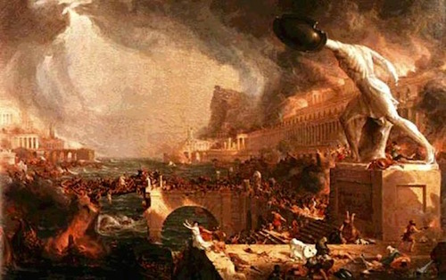
Graphic: Picture of Tacitus
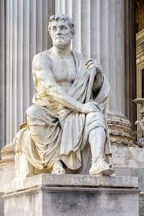

Reading of the word:
1 Peter 1:22-25 - 22 Since you have purified your souls in obeying the truth through the Spirit in sincere love of the brethren, love one another fervently with a pure heart, 23 having been born again, not of corruptible seed but incorruptible, through the word of God which lives and abides forever, 24 because
“All flesh is as grass,
And all the glory of man as the flower of the grass.
The grass withers,
And its flower falls away,
25 But the word of the Lord endures forever.”
Now this is the word which by the gospel was preached to you.

Main scripture for the remainder of message:
1 Peter 2:1-9 - 2 Therefore, laying aside all malice, all deceit, hypocrisy, envy, and all evil speaking, 2 as newborn babes, desire the pure milk of the word, that you may grow thereby, 3 if indeed you have tasted that the Lord is gracious.
4 Coming to Him as to a living stone, rejected indeed by men, but chosen by God and precious, 5 you also, as living stones, are being built up a spiritual house, a holy priesthood, to offer up spiritual sacrifices acceptable to God through Jesus Christ. 6 Therefore it is also contained in the Scripture,
“Behold, I lay in Zion
A chief cornerstone, elect, precious,
And he who believes on Him will by no means be put to shame.”
7 Therefore, to you who believe, He is precious; but to those who are disobedient,
“The stone which the builders rejected
Has become the chief cornerstone,”
8 and
“A stone of stumbling
And a rock of offense.”
They stumble, being disobedient to the word, to which they also were appointed.
9 But you are a chosen generation, a royal priesthood, a holy nation, His own special people, that you may proclaim the praises of Him who called you out of darkness into His marvelous light; 10 who once were not a people but are now the people of God, who had not obtained mercy but now have obtained mercy.
Discussion of Peter:
Matthew 16:18: “And I also say to you that you are Peter, and on this rock I will build my church, and the gates of Hades shall not prevail against it.”
And:
“And I also say to you that you are petros (a little stone), and on this petra (A big rock, cliffs, craigs), and the gates of Hades (the place of punishment, the entry of which is death – the gates of Hades would have been a Jewish phrase meaning death.)
Graphic – Pics of Cornerstones:
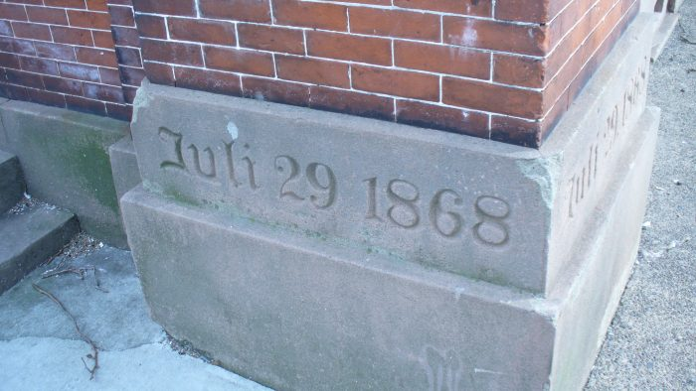
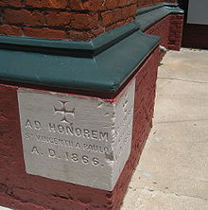

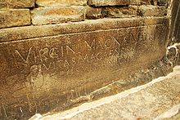

Living Stones verses:
- New life in Christ (2 Cor 5:17) 17 Therefore, if anyone is in Christ, the new creation has come:[a] The old has gone, the new is here!
- Security in Christ (John 6:37) 7 All those the Father gives me will come to me, and whoever comes to me I will never drive away.
And back to the main scripture again
- 1 Peter 2:1-9 - 2 Therefore, laying aside all malice, all deceit, hypocrisy, envy, and all evil speaking, 2 as newborn babes, desire the pure milk of the word, that you may grow thereby, 3 if indeed you have tasted that the Lord is gracious.
- 4 Coming to Him as to a living stone, rejected indeed by men, but chosen by God and precious, 5 you also, as living stones, are being built up a spiritual house, a holy priesthood, to offer up spiritual sacrifices acceptable to God through Jesus Christ.

